Table AX. All fires from FRAP (2017) perimeter database the burned within SCB. Fires included in the analysis burned 57% of SCB.

|  |  |  |  |  |  |
| --- | --- | --- | --- | --- | --- |
| Year | Name | Report date | Total area (ha) | Area of watershed burned (ha) | Included in analyses? |
| 1952 | Sugarloaf | 19-Jun | 15 | 15 |  |
| 1964 | Williams | 2-Oct | 5 | 5 |  |
| 1971 | Ball Dome | 13-Aug | 99 | 99 |  |
| 1972 | Sugar Valley | 15-Sep | 16 | 5 |  |
| 1973 | So. Sentinel | 28-Aug | 1084 | 1038 | Y |
| 1974 | Comanche | 22-Jul | 1219 | 1219 | Y |
| 1976 | In Between | 29-Jul | 13 | 13 | Y |
| 1977 | Sugarloaf | 20-Jul | 264 | 264 | Y |
| 1977 | Ferguson | 26-Jun | 4219 | 1594 | Y |
| 1980 | Roaring | 1-Aug | 170 | 72 | Y |
| 1985 | Sugarloaf | 28-Jul | 1153 | 1152 | Y |
| 1988 | Sugarbaby | 20-Jun | 3 | 3 | Y |
| 1992 | Ellis Meadow | 2-Jun | 23 | 23 | Y |
| 1997 | Sugarloaf | 15-Aug | 114 | 114 | Y |
| 1999 | Williams | 18-Sep | 232 | 232 | Y |
| 2003 | Williams | 28-Jul | 1429 | 1427 | Y |
| 2004 | Ferguson | 7-Jul | 1 | 1 |  |
| 2006 | Pond | 13-Aug | 5 | 0 |  |

# Appendix A: Sugarloaf Creek Basin and Illilouette Creek Basin weather station sites

At Sugarloaf, comparison between manually collected soil moisture data measured in a grid around each weather station site and weather station recorded 12 cm soil moisture was made. For a spring date of May 23rd, 2017, manually collected soil moisture data for wetland, shrub, and forest stations were 48%±13%, 7.5%±1.8%, and 8.7%±2.3% respectively. For the same collection date, the wetland, shrub, and forest weather stations’ 12 cm soil moisture sensors have measured 49%, 10%, and 11% respectively. For a late summer date of August 5th (wetland and forest) and 9th (shrub), 2017, manually collected soil moisture data for wetland, shrub, and forest stations were 41%±14%, 1.0%±0.6%, and 1.3%±1.2%. For the same collection dates, the wetland, shrub, and forest weather stations’ 12 cm soil moisture sensors have measured 49%, 2.2%, and 2.9% respectively. It appears that manually sampled soil moisture is consistently lower than soil moisture data measured by the weather stations at equivalent depths. This is unsurprising because manually collected soil moisture measures average soil water content vertically from the surface to the depth of 12 cm. Meanwhile weather station’s moisture probe measures average soil water content horizontally at the depth of 12 cm.

Cumulative shallow soil moisture gain (Table 1) was calculated from depth and time integrated soil moisture timeseries. Cumulative soil moisture is another metric to gauge how much water shallow soils have received. It is a useful metric to approximate precipitation amounts when the tipping bucket record is missing or not reliable. Although in the case of saturated wetland sites, water gain cannot be calculated.

Soil samples were collected during installation of the soil moisture probes at each weather station, and analyzed for organic matter content as well as soil texture. Soil types were loamy sand or sand at all sites and depths, with shallow wetland soils in both ICB and SCB showing higher organic matter and silt content (Table A.1).

|  |  |  |  |  |  |  |
| --- | --- | --- | --- | --- | --- | --- |
| Watershed | Site | Depth (cm) | Sand % | Silt % | Clay % | OM % |
| ICB | Wetland | 0-10 | 71.3 | 10.4 | 6.1 | 13.0 |
| 50-60 | 84.4 | 7.9 | 5.9 | 1.8 |
| 90 | 88.8 | 4.9 | 4.9 | 1.3 |
| Near Wetland | 0-10 | 86.8 | 3.9 | 5.8 | 3.5 |
| 20-30 | 85.5 | 5.8 | 5.8 | 2.8 |
| Shrub | 0-10 | 88.0 | 5.9 | 3.9 | 2.2 |
| 50-60 | 89.8 | 3.9 | 4.9 | 1.3 |
| 90-100 | NA | NA | NA | 1.3 |
| Forest | 0-10 | 87.6 | 5.9 | 4.9 | 1.6 |
| 50-60 | 90.8 | 3.0 | 4.9 | 1.3 |
| 90-100 | 89.9 | 4.0 | 4.9 | 1.2 |
| SCB | Wetland | 0-12 | 72.9 | 13.1 | 7.5 | 6.5 |
| 50 | 80.2 | 8.8 | 8.8 | 2.3 |
| 100 | 79.4 | 9.8 | 8.8 | 2.0 |
| Shrub | 0-12 | 87.9 | 3.9 | 5.9 | 2.4 |
| 50 | 88.4 | 3.9 | 4.9 | 2.9 |
| 100 | 87.7 | 4.9 | 5.9 | 1.4 |
| Forest | 0-12 | 85.1 | 4.8 | 5.7 | 4.4 |
| 48 | 88.8 | 3.9 | 4.9 | 2.4 |
| 100 | 87.1 | 5.9 | 4.9 | 2.2 |

*Table A.1: Soil texture and organic matter (OM) percent composition for soil samples collected at the weather stations at different depths. An additional dense meadow site near the wetland weather station in ICB is also shown for comparison. Insufficient sample was available to calculate texture at the ICB shrub site.*

Differences in weather station vegetation between ICB and SCB do exist. The SCB wetland site contains larger portion of conifer regeneration in comparison to ICB which is predominantly vegetated with tall grasses. The shrubland site in ICB prior to the Empire Fire in the fall of 2017 was comprised mostly of whitethorn ceanothus (*Ceanothus cordulatus*). The Empire fire burned the shrub site at high severity, resulting in bare soils with little live vegetation for the following 2018 WY. In comparison, the SCB shrub site contains a dense growth of young conifers with a mix of ceanothus. Forest sites are similar in tree density, tree species, and slope for both ICB and SCB. Refer to Figure A.1 for imagery of SCB weather stations, Figure A.2 for pre-Empire fire ICB weather stations.

Weather station data support greater water inputs into ICB than SCB (Table 1). Total precipitation in ICB was 1.3-1.6 times the total precipitation in SCB for the wet 2017 WY. For the drier 2018 WY, total precipitation in ICB was between 1.1-1.2 times precipitation in SCB. Precipitation totals for ICB are conservative for 2017 WY because of the removal of the weather stations prior to the Empire Fire (September through the end of November). There were at least two non-recorded precipitation events during the time the stations were non-operational. Comparing the weather station precipitation estimates to PRISM data (<http://www.prism.oregonstate.edu>) at the same locations shows the same general trends in space and time, giving us high confidence in our calculated precipitation trends even if the exact values do not agree (Table A.2). PRISM precipitation is highly uncertain in the Sierra Nevada, and therefore we do not believe that the differences in annual total precipitation necessarily indicate an error in our measurements (CITE). However, the fact that our weather stations consistently estimated less precipitation than PRISM could be partly due to precipitation that was not captured by our gauges due to damage from animal activity or extreme weather.

|  |  |  |  |
| --- | --- | --- | --- |
|  | **WY 2016** | **WY 2017** | **WY 2018** |
| Weather Station, ICB | ? | 1,130 mm | 560 mm |
| PRISM, ICB | 1,028 mm | 2,017 mm | 797 mm |
| Weather Station, SCB | NA | 780 mm | 490 mm |
| PRISM, SCB | 843 mm | 1,491 mm | 673 mm |
| ICB/SCB, weather stns. | NA | 1.45 | 1.14 |
| ICB/SCB, PRISM | 1.22 | 1.35 | 1.19 |
| PRISM/Station, ICB | ? | 1.78 | 1.42 |
| PRISM/Station, SCB | NA | 1.91 | 1.37 |

*Table A.2. Annual precipitation estimates for water years (WY) 2017 and 2018. Weather station estimates are averaged between the non-forest stations at each watershed (ICB and SCB) as these stations should not experience interception losses. The ratio of precipitation between sites and between datasets show that for 2016-2018 ICB always received more annual precipitation than SCB (regardless of dataset), and PRISM always estimated higher precipitation than our weather stations.*

ICB and SCB showed similar temperatures. On average, SCB is 0.3 degrees Celsius cooler in the summer and 0.2 degrees cooler in the winter than ICB with average summer temperatures of 15.7 degrees Celsius and average winter temperatures of -1.1 degrees Celsius. In SCB, the forest station is on average 0.6 degrees warmer than the wetland station, and 0.1 degrees warmer than the shrub station. That difference is even greater in ICB where the forest station is on average 1.2 degrees warmer than the wetland station and 0.3 degrees warmer than the shrub station (Figure A.5).



**Shrub**

**Wetland**



**Forest**

Figure A.1: Images of weather stations taken by installed snow cameras in Sugarloaf Creek Basin. Top image is of the wetland site, middle is of the shrub site, and bottom is of the forest site.



**Wetland**



**Forest**

**Shrub**

Figure A.2: Images of weather stations taken on October 11th, 2015 by installed snow cameras in Illilouette Creek Basin. Top left image is of the wetland site, bottom left is of the shrub site, and right image is of the forest site.

Similarly to Figure 10 in the Soil Moisture section of Results, figure A.4 provides soil moisture data in ICB at 12, 60, and 100 cm depths as recorded by the wetland, shrub, and forest weather stations. Gray shading signifies presence of snow around weather station’s base for a given time period.



Figure A.4: volumetric water content [%] shallow (12 cm), mid (60 cm), and deep (100 cm) soils as measured by wetland (top plot), shrub (middle plot), and forest (bottom plot) weather stations in Illilouette Creek Basin. Data was measured at 10 minute intervals for part of 2016, 2017 and 2018 water years. Daily precipitation in the form of rain and snow melt is presented as vertical bars. Gray horizontal lines represent period of time when snow is present around the base of the weather station. Water year (WY) summaries are also provided for total precipitation recorded at each station. The Empire fire has burned through the area where the stations were installed, resulting in the prior removal of the station and lack of data for the month of September through November 2017.

Figure A.5 provides summaries of the mean temperature for each month at each weather station for both SCB and ICB. On average, SCB is 0.3 degrees cooler in the summer than ICB, and 0.2 degrees cooler in the winter. For both SCB and ICB, forest station is generally the warmest and wetland station is the coolest year around with the greatest difference in the winter months.



Figure A.5: Mean monthly temperatures for SCB’s (top), and ICB’s (bottom) weather stations for 2017 and 2018 water years for forest, shrub, and wetland stations.

For both ICB and SCB, the majority of the precipitation is in the form of snow. Differences in snowpack depth between the three stations was observed (Figure A.6). Sugarloaf has missing snow depth data due to cameras being covered with snow for much of the 2017 WY. However, it is clear that SCB had more snow that winter than ICB. Snow depth was comparable between the two sites during the 2018 WY. In ICB manual snow depth measurements were taken in a grid around each weather station in March 2016, January and April 2017, and March 2018 (Figure A.6). For both locations and all water years, the wetland station on average had the greatest snow depth with the latest melt date, followed by the shrub station. Forest station had the lowest snowpack depth and earliest melt date.

**

Figure A.6: Snow depth (in mm) for Sugarloaf Creek Basin (top) and Illilouette Creek Basin (bottom) as measured from images taken four times each day at wetland, shrub, and forest weather station sites. Additionally, error bars (squares indicating mean, and bars indicating standard deviation) are shown for manually measured snow depths in ICB.

# Appendix B: Precipitation Gap Filling

The first step in obtaining accurate precipitation timeseries was to remove all incorrect precipitation records. This includes times when the rain gauge is upside down or damaged in any other visible way, or when false precipitation measurements are clearly caused by a person or animal moving the gauge (e.g., when maintenance occurred or when time lapse cameras show that an animal disturbed the station). The next step was to set precipitation record as missing for the times when the station recorded zero precipitation, but the surrounding stations have recorded a precipitation event and there was a pulse in shallow soil moisture content. This type of missing data has mostly occurred in the winter months when the tipping bucket was likely to be frozen and/or the rain gauge was covered with snow. After this step, in Sugarloaf Creek Basin, 32% of precipitation at the forest, 25% at the shrub, and 27% at the wetland station was missing. In Illilouette Creek Basin, these percentages were: 24%, 10%, and 19% respectively.

If all three stations were missing precipitation record, then a combination of snow melt amounts and shallow soil water inputs was used to gap-fill the record (Figure B.1). Snow melt was measured as a decrease in snow depth. Snow depth was converted to water equivalent using density of 0.4. and then was rounded to the nearest 0.1 inch to match the resolution of the precipitation gauge. Due to the record snowpack in 2017 water year (WY), we were not able to measure snow depths above the height of the camera (~220 cm) in SCB. Shallow soil water inputs were estimated by smoothing 10-min soil moisture content at the depth of 12 cm, and then depth integrating moisture content over the time series. Positive change was counted as water accumulation, and negative change was counted as water loss. While shallow soil water input metric is not a good approximation for the precipitation amount, it is a good metric to detect precipitation and melt events in the absence of rain gauge data.

In the final step, a predictive mean matching (mice.impute.pmm function in R package “MICE”) was used to perform multiple imputations of the missing data when there was record for at least one station. Predictive mean matching (Little and Statistics 1988) is an advantageous technique for large datasets having non-normal distributions, and discrete values with physical bounds (in our case precipitation cannot be less than zero). Five imputations were performed with a random selection of one observed value from a pool of 5 donors of the closest predicted values. After this step, precipitation record was complete with no missing values. All predictions were rounded to the nearest 0.1 inch (2.54 mm), since that is the smallest measurement detected by the rain gauge.







Figure B.1: Tipping bucket, snow melt, and shallow soil water inputs records for forest (top), shrub (middle), and wetland (bottom) stations in SCB.

**Literature Cited**

Little, R. J. J. J. o. B., and E. Statistics. 1988. Missing-data adjustments in large surveys. Journal of Business & Economic Statistics **6**:287-296.

# Appendix C: Detailed soil moisture model results

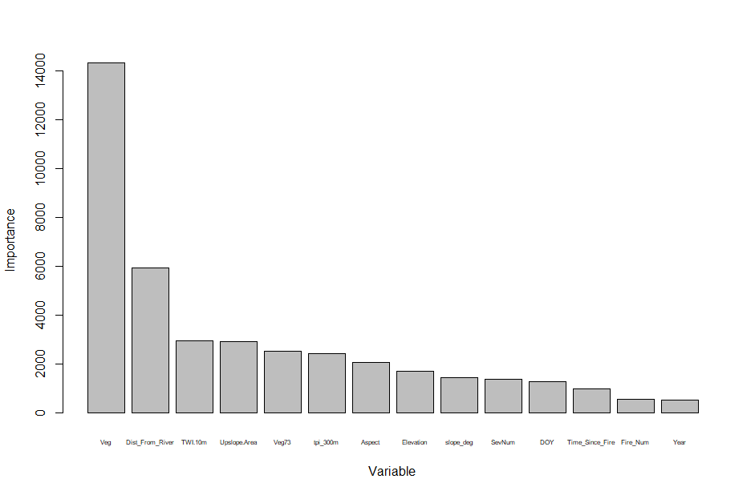

Figure C1: Relative importance of each variable in predicting plot-level soil moisture. Variables include 2014 vegetation (Veg), Distance from nearest stream, topographic wetness index at a 10m resolution (TWI.10m), Upslope contributing area, 1973 vegetation (Veg73), topographic position index calculated at a scale of 300m (tpi_300m), aspect, elevation, slope, maximum fire severity (SevNum), days since January 1 for the measurement (DOY), years since fire, times burned, and year of the measurement.



Figure C1b: Importance plot for ICB data.

*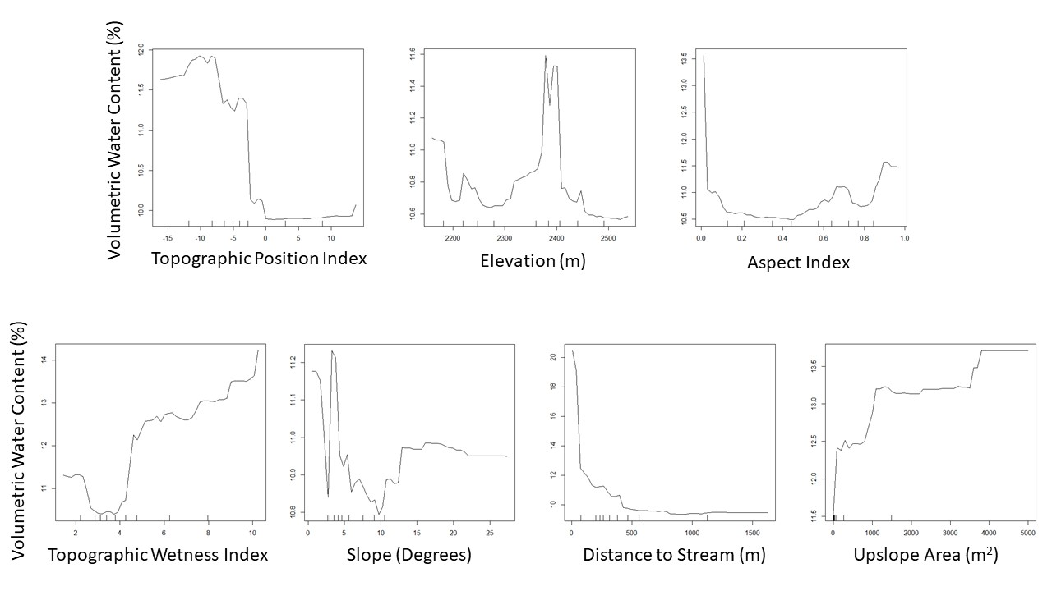Figure C2: Partial plots showing how the mean soil moisture (across all other possible variable values) varies with each topographic variable.*

*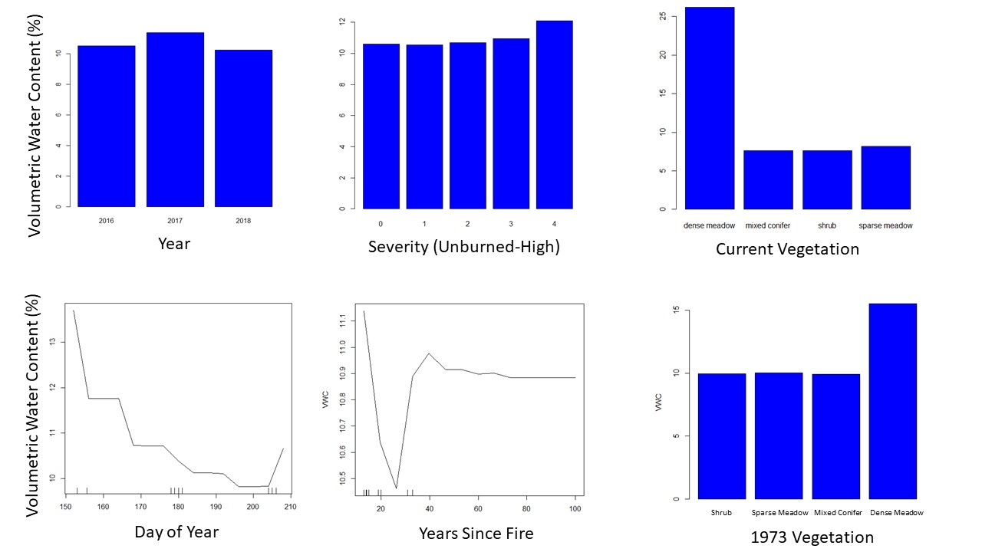Figure C3: Partial plots showing how the mean soil moisture (across all other possible variable values) varies with each variable. Those variables treated as factors rather than numbers in the model are shown as bar plots. Number of fires varied moisture by less than 0.4%, and is not shown.*



Figure C4. Modeled versus measured soil moisture in SCB (site means). Red points are calculated using a model trained on ICB data; black points are from a model trained on SCB data.



Figure C5. Errors in predicting SLB soil moisture using a model trained on SLB data (grey) and on ICB data (red).

Appendix D: Details of landscape changes

**Methods:**

In order to quantify landscape changes in SCB, as well as compare these changes to ICB, we used the FRAGSTATS package to calculate various land cover metrics.

For both ICB and and SCB, the land cover was divided into four broad vegetation classes: forest, shrub, sparse meadow, and dense meadow. Areas south of the southernmost extent of historical fires were removed from the landscape change analysis, since this area consisted mostly of isolated patches of vegetation surrounded by rock and caused misleading values. Isolated pixels surrounded by different vegetation types were removed from the maps before processing by merging them with the surrounding vegetation type; this minimized differences caused by small isolated patches that were likely due to classification error or would be difficult to capture the same way using two sets of imagery.

For SLB, calculations were performed on vegetation maps created from images taken in 1973 and 2014. For ICB, the imagery dates from 1969/70, 1987, 1997, 2005, and 2012. For both watersheds, the first year of imagery (either 1973 or 1969/70) coincides with the end of a long period of fire suppression, prior to the use of managed wildfire.

Landscape Metrics:

Diversity indices have been shown to capture fire-related landscape changes well (Romme, 1982). They describe heterogeneity by measuring how patches of vegetation are distributed spatially across the landscape. We evaluated the following diversity metrics:

Shannon’s Evenness Index (SHEI) is the Shannon’s Diversity Index (calculated using information theory) divided by the maximum diversity given the number of cover types present (McGarigal et al., 2012). An evenness index of 1 would mean that all vegetation types were equally represented in the landscape; higher evenness means more landscape diversity.

Simpson’s Evenness Index (SIEI) is similar, but is calculated using the probability that any two cells selected at random would be different patch types (McGarigal et al., 2012). Again, a value of 1 would mean that all patch types cover an equal area, and a value near 0 would mean that one type dominated nearly all of the landscape. We include both evenness indices in order to verify that the exact method of calculating evenness does not affect our results.

Aggregation Index (AI) is a measure of how much each vegetation type is clumped into a few large groups (high aggregation) or spread into many small groups (low aggregation).

Patch properties within each class:

Patch properties describe local-scale heterogeneity and the size and shape of individual vegetation patches. For this study, we selected metrics which have been shown to be consistent across many different landscapes (Cushman et al., 2008):

Largest patch percent area (LPI) gives the percent of the total vegetated area taken up by the largest contiguous vegetation patch within each vegetation class. This metric gives an idea of the maximum area dominated by a single type of overstory.

Fractal dimension (FRAC) measures how complex and plane-filling the shapes are by using the relationship between the area and perimeter of a patch. As the dimension approaches 2, perimeter is maximized for a given area of coverage, while for simple geometries such as squares or circles the dimension is 1 (McGarigal et al., 2012). For example: a vegetation class with a low fractal dimension whose largest patch covers a large area indicates a spatially homogeneous region. On the other hand, a high fractal dimension suggests an increase in the total length of boundaries between patches of different types, thus increasing local heterogeneity.

In addition to these metrics, we calculated the mean and standard deviation of the areas of all patches within each vegetation class. These measures help capture the changes in the distribution of patch sizes.

All calculations were made on a rasterized vegetation map with a spatial resolution of 5 meters. This spatial resolution was chosen to match with calculations made on ICB vegetation (CITE Boisrame et al. FEM).

**Results and Discussion:**

Sugarloaf Creek Basin (SCB) showed a much smaller degree of landscape change than Illilouette Creek Basin (ICB). Diversity indices increased over time for both watersheds, but the change was negligible for SLB, showing that landscape diversity rose only very slightly in response to fire (Figure D1). The landscape-scale aggregation index increased slightly over time in SLB, in contrast to a decrease in ICB (Figure D2). This could be due to fires creating larger areas of sparse meadow that are more aggregated than pre-burn meadow areas (Figure D3b). The size of the largest vegetation patches did not vary appreciably in SLB between 1973 and 2014, with the exception of sparse meadows (Figure D3). The mean and standard deviation of patch sizes, however, showed similar trends to ICB (Figure D4). Most notably, conifer patches got smaller and less varied in size following 4 decades of fire (Figure D4). While fractal dimension increased for all vegetation types in ICB, it remained flat or decreased slightly in SLB (Figure D5). This may partially be due to fires creating a small number of new fairly homogeneous patches with simple geometries, but the small amount of change demonstrates that patch properties varied very little in response to fire in SLB.

Relative proportions of each vegetation type were similar between the two watersheds (Figure D6; note that these proportions do not account for exposed rock). Both watersheds also had similar Shannon’s Evenness Index values in their pre-fire/post-suppression states (Figure D1). These similarities show that, despite differences discussed in the main text, the large-scale land cover types and distributions are comparable between these watersheds, making them useful to use as two case studies demonstrating how fire affects two similar landscapes in areas with slightly different climatology and geology.

*Figure D1. Shannon’s Evenness Index calculated for both ICB and SLB for each year that we created vegetation maps from aerial imagery.*

*Figure D2. Aggregation Index calculated for both ICB and SLB for each year that we created vegetation maps from aerial imagery.*

a)

b)

*Figure D3. Largest patch index (LPI; the percent of the total area occupied by the largest contiguous patch of vegetation) for each vegetation class for both ICB and SLB. Conifer (a) is shown separately from the other vegetation classes (b) due to large differences in scale.*



(c) (d)

*Figure D4. Mean and standard deviation of patch size for each vegetation class for both ICB (a-b) and SLB (c-d). Conifer is shown separately from the other vegetation classes due to large differences in scale.*

*Figure D5. Mean area-weighted fractal dimension of patches for each vegetation class for both ICB and SLB.*

*Figure D6. Percent of the total vegetated area covered by each vegetation class for both ICB and SLB. Conifer is shown separately from the other vegetation classes due to large differences in scale.*